|  |  |  |
| --- | --- | --- |
| Temasek Polytechnic | Description: ENG Logo | |
| Computer Programming for Problem Solving (ESE1006) – Project | | |
| Name: | | | Class: | |
| Tutor’s Comments: | | | Matric No: | |

**Project Specification**

1. **Problem Specification**
   1. Brief Description

To use the Monthly Electricity Consumption by public and private dwelling types (GWh) in Singapore for the year 2019 data in a python program and display 4 different menu options plus a Quit option.

Type of input data

A CSV file is used as the data source – sgallelectricity_dataset.csv

Amount of input data

The dimension of the input data is 12x5 (12 rows and 5 columns).

1. **Problem Analysis:**

You are required to analyse at least 2 functionalities to pass (Analyze all 4 to get more marks)

The program starts by displaying the main menu, which allows the user to enter a choice of 4 different menu options plus a Quit option. The dataset is a CSV file and therefore pythons default csv package is used to read the data. Matplotlib and NumPy are used for plotting. All options are described in detail below.

First option is to display the monthly electricity consumptions of all dwelling types in May. It can be done by iterating through the data collecting all the data for dwelling types in May.

Second option is to display the mean value of the electricity consumption in each of the 4-month periods from Apr to Jun & from Oct to Dec and also to get the maximum electricity consumption in each of the periods and the months in which it occurred. The first sub-problem can be solved using the inbuilt mean() function. The mean() function in the python statistics library can be used to directly compute the average of a list. Next, print the max value from the list.

Third option is to display the electricity consumption and the months in which the monthly electricity consumption is at least 6% higher than the annual mean electricity consumption, for the user selected type. The index of the given type can be passed to the sorted data source and hence, returns the solution.

Finally, the fourth option is to create a:

1. Line plot
2. Bar chart

Matplotlib and NumPy can be used for plotting in python. Problem Statement 1 (Function 1)

What are the input data and how are they acquired?

The input data is a CSV file (sgallelectricity _dataset.csv) of size 12x5. Python’s default csv package is used to read the data. The csv.reader() function returns the data in a 2-dimensional matrix. This dataset is passed to the Main function.

What are the required output data?

The required output data is monthly electricity consumptions of all dwelling types in May.

How do you get the required output(s)?

* Iterating through the dataset to find the index of the required type.
* Using that index to access the monthly electricity consumptions value corresponding to each type.

Problem Statement 2 (Function 2)

What are the input data and how they acquired?

The input data is a CSV file (sgallelectricity _dataset.csv) of size 12x5. Python’s default csv package is used to read the data. The csv.reader() function returns the data in a 2-dimensional matrix. This dataset is passed to the Main function.

A user selected dwelling type is also passed as a parameter.

What are the required output data?

The required output data is:

* The average electricity consumption in each of the 4-month periods from Apr to Jun & from Oct to Dec.
* The maximum electricity consumption in each of the periods and the months in which it occurred.

How do you get the required output(s)?

* Iterating through the data and calculate the average using python’s mean function.
* Finding the max value from the list and its corresponding month.

Problem Statement 3 (Function 3)

What are the input data and how they acquired?

The input data is a CSV file (sgallelectricity _dataset.csv) of size 12x5. Python’s default csv package is used to read the data. The csv.reader() function returns the data in a 2-dimensional matrix. This dataset is passed to the Main function.

A user selected dwelling type is also passed as a parameter.

What are the required output data?

The required output data is:

* Display the electricity consumption and the months in which the monthly electricity consumption is at least 6% higher than the annual mean electricity consumption.

How do you get the required output(s)?

* Iterating through the data.
* Check if the monthly consumption is at least 6% or higher than the calculated annual mean electricity consumption.

Problem Statement 4 (Function 4)

What are the input data and how are they acquired?

The input data is a CSV file (sgallelectricity _dataset.csv) of size 12x5. Python’s default csv package is used to read the data. The csv.reader() function returns the data in a 2-dimensional matrix. This dataset is passed to the Main function.

* Private Apts/Condo, Landed Properties (of each month) and corresponding Month as python lists.
* Total Electricity Consumption, Public Housing (of each month) and corresponding Month as python lists.

What are the required output data?

The required output is:

* A line plot with x-axis as Months and y-axis as Private Apts/Condo, Landed Properties (of each month).
* A bar chart with x-axis as Months and y-axis as Total Electricity Consumption, Public Housing (of each month).

How do you get the required output(s)?

* First, required variables are initialized and declared with its respective values.
* For the line plot, Matplotlib.plot() function can be used.
* For the bar chart, Matplotlib.bar() function can be used.

1. **Problem Design**

Flowchart of *main* function

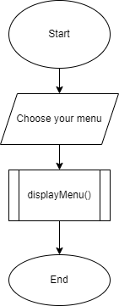

Flowchart of *displayMenu* function

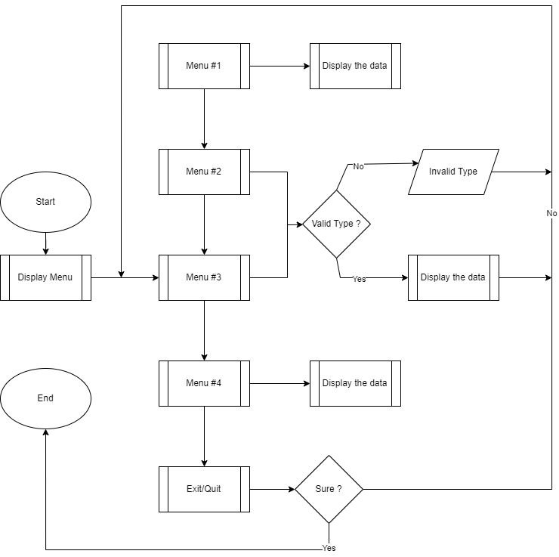

1. **Flow Charts for the 4 functions to be added here. Add as many pages as needed**

